**CCDA Aggregator Batch Process**

1. Download the jar file from <https://github.com/siteadmin/scorecard-batch/tree/master/artifacts>
2. Please create/update the config file ccdaaggregator-batch.config with the following properties:

* ccdaaggregator.ccdaFolderLocation =folder location of ccda files
* ccdaaggregator.outputFolderLocation =folder location to write failures (if any)
* ccdaaggregator.ccdaAggregatorUrl =http://localhost:8080/ccda-aggregator/QueryInformation/ (url of ccda aggregator server)

A sample config file can be found at <https://github.com/siteadmin/scorecard-batch/blob/master/src/main/resources/scorecard-batch.config>

1. **Open Command Prompt and Run As Administrator**. Navigate to the location where the jar file is placed. For example, the jar file is placed under C:\Projects.

Execute the following command.

java -DconfigFileLocation="C:/var/opt/ccdabatch/ccdaaggregator-batch.config" -jar ccda-aggregator-batch.jar

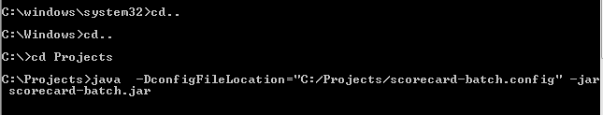

1. The batch will process all the folders available in given location and writes any failures to given outputFolderLocation.